**Project Report.**

**Database Design for Health Care Systems, Hospital Management.**

**Introduction:**

It is difficult and not so efficient to maintain hard copies in the field of medical Health Sciences. When it comes to maintaining a hospital, it makes difficult for the management to keep track their hand copies about their patients which needs huge warehouses to keep the documents. So, we decided to develop an application for easy access for the patients to track their bills, knowing available timings of the doctors, to get their medication bills.

**Objective:**

To develop a day-to-day record on state of the patients, doctors, reports. It is designed to achieve the following objectives:

* To computerize all details regarding and doctors.
* Fixing the appointment timings.
* The patients can view their billing info from their respective authorized login.
* The info. of the patients are updated and stored in the database for future purposes.

**Requirement Analysis.**

**Data Requirements:**

* In this hospital management system, patient, doctor, and receptionist are the departments we have. We can also develop web application for this system.
* Patients department have the values such as patient name, address (city, state, zip), mobile number, birthdate, date they are consulting the doctor and a unique id to identify the person.
* Patient access the system through their login details which are loaded into the database during registration.
* Doctors treat the patients and can view their patient’s timings. Doctors have their name, designation, experience and identified uniquely by their doctor id.
* Receptionist generates the bills and sends them to the patient which including the treatment the patients have taken and billed amounts.
* Receptionist is responsible for sending the bills to the patients, the doctor can treat many patients and customers can get treated from many doctors.

**Conceptual Design:**

We are going to use three tier architecture which comprises of

* Database layer
* Business layer
* Graphical user interface

Database

Graphical User Interface

Application program webpage

***Scope:***

To facilitate easy appointments for both doctors and patients, Health records management and Medical expense management Records efficient maintenance.

### Part 1: Revised your ER diagram

ENTITY RELATIONSHIP MODEL (ERM) OF THE DESIGN

Entity relationship model is the conceptual representation of data; it is a database modeling method that is used for producing semantic data model of a system. Diagrams created by this process are called entity relationship diagrams. The entity relationship of the design shows how two or more entities are related to one another. Each entity must have a minimal set of uniquely identifying attributes which is called the entity’s primary key.

There are three types of key

1. **PRIMARY KEY (pk):** The primary key is like a field name which can be used to uniquely identify a given record in a database table.
2. **FOREIGN KEY (fk):** Is a key in a table ‘’schema’’ that is a primary key in another table schema of a database.
3. **UNIQUE KEY (uk):** Is a key in a table schema which is not a primary key but can uniquely identify a record in table schema.

### HMS ER Diagram.

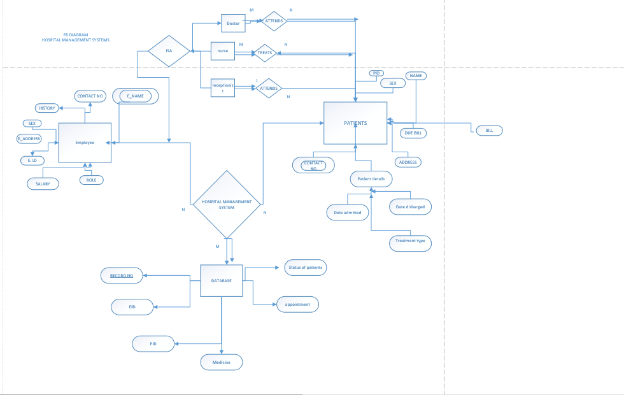

Hospital Employee Table’s ER diagram.

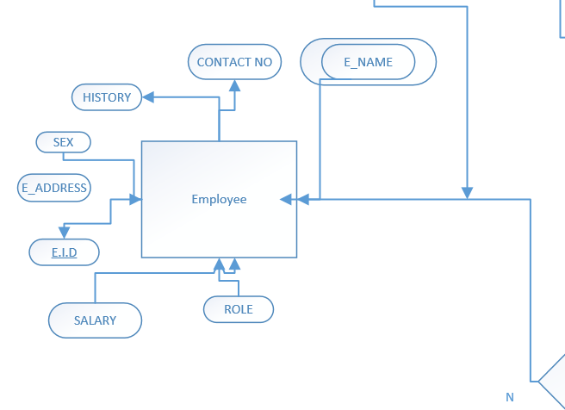

All Patient Record Database ER:

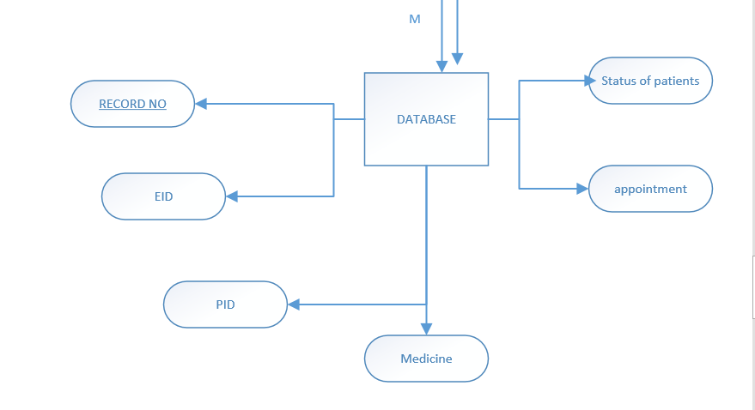

Individual Patient Database Record’s ER:

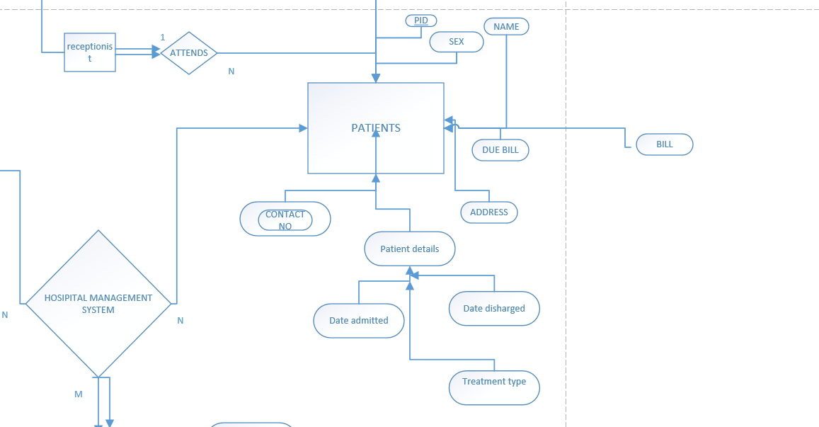

## DATABASE SCHEMA

Database schema is the structure of the database that defines the objects in the database. A schema is a collection of logical structures of data, or schema objects. A schema is owned by a database user and has the same name as that user. Each user owns a single schema. Schema objects can be created and manipulated with MySQL and include the following types of objects:

* Clusters
* Database links
* Database triggers
* Dimensions
* External procedure libraries
* Indexes and index types
* Java classes, Java resources, and Java sources
* Materialized views and materialized view logs
* Object tables, object types, and object views
* Operators
* Sequences
* Stored functions, procedures, and packages
* Synonyms
* Tables and index-organized tables
* Views

Other types of objects are also stored in the database and can be created and manipulated with MySQL but are not contained in a schema:

* Contexts
* Directories
* Profiles
* Roles
* Tables paces
* Users
* Rollback segments -

There are **four levels** of database schema thus:

1. **Conceptual schema:** is a map of concepts and their relationships. This describes the semantics of an organization and represents a series of assertions about its nature. Specifically, it describes the things of significance to an organization (entity classes), about which it is inclined to collect information, and characteristics of (attributes) and associations between pairs of those things of significance (relationships).
2. **Logical schema**: is a map of entities and their attributes and relations. The logical schema was the way data were represented to conform to the constraints of a particular approach to database management. Logical Schema is a data model of a specific problem domain expressed in terms of a particular data management technology.

1. **Physical schema**: is a particular implementation of a logical schema. It describes how physically data would be stored on disk drives.
2. **Schema object:** is an Oracle database object. Schema objects are logical data storage structures. Schema objects do not have a one-to-one correspondence to physical files on disk that store their information. However, Oracle stores a schema object logically within a table space of the database. The data of each object is physically contained in one or more of the table space’s data files. For some objects, such as tables, indexes, and clusters, you can specify how much disk space Oracle allocates for the object within the table space’s data files.

There is no relationship between schemas and table spaces: a table space can contain objects from different schemas, and the objects for a schema can be contained in different table spaces.

Appointment

Hospital Details

Registration type

Registration number

Registration date

First name

Last name

Other names

Sex

Day of birth

Home address

Place of origin

Nationality

Phone number

Alternate Number

Appointment id

Subject

Date visited

Appointment time

Patient id

Specialist

Detail

Appointment

**Doctor Table Schema**: Doctor Register(id:Integer,Specilization: Varchar, Doctorname:Varchar,address:longtext,docFees:Varchar,contactno:bigint,docEmail:varchar,password:varchar,creationDate:timestamp,updationDate: Varchar).

The below table stores the details of the doctors when they register with the HMS application.

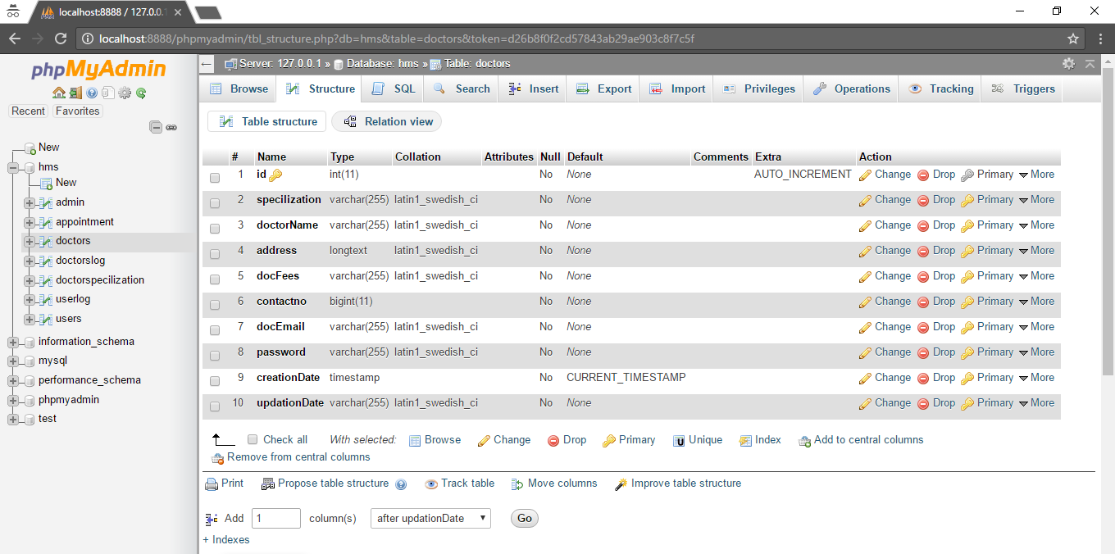

**Doctor Specilization Table Schema**: Specilization: (id: Integer, Specilization:Varchar,,creationDate:timestamp, updationDate: Varchar).

The below table stores the details of the doctors specialization. It is created by admin.

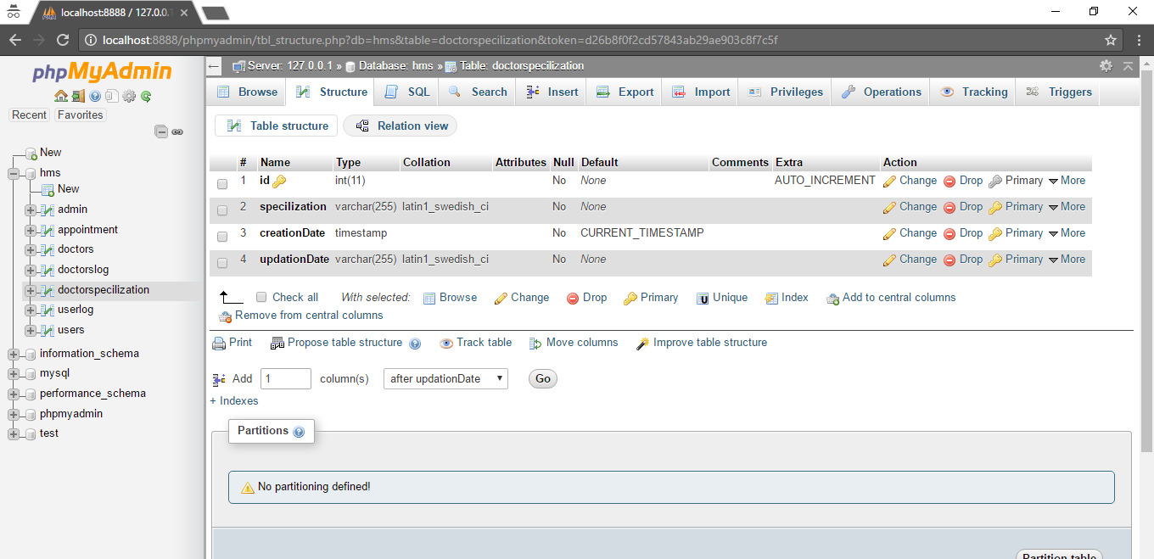

**Patient appointment Table Schema**: appoinmtnet(id: Integer, doctorSpecilization: Varchar, Doctorname: Varchar,doctored: int, userid: int, consultancyFees:int, appointmentdate: varchar, appointmentTime: Varchar, postingdate: varchar, userid: int, creationDate: timestamp, updationDate: Varchar).

The below table stores the details of the appointment request made by the patient.

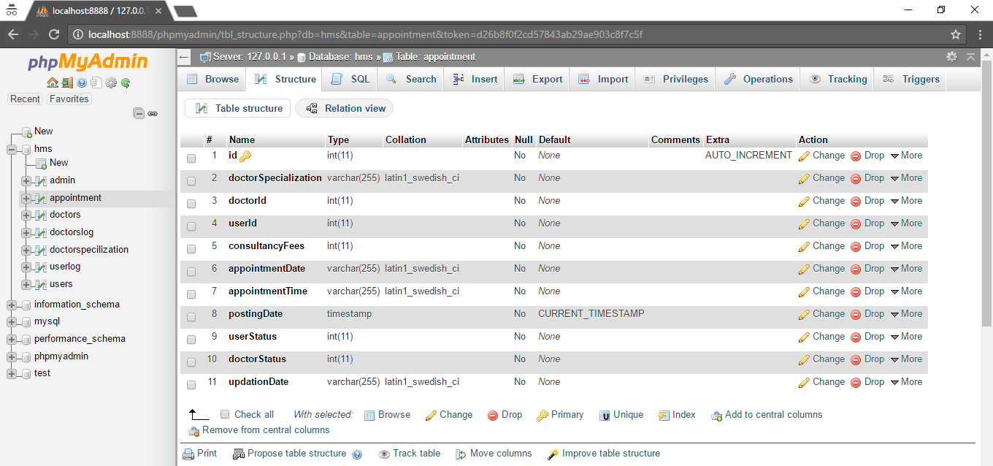

**Web Application.**

**UML Diagram:**

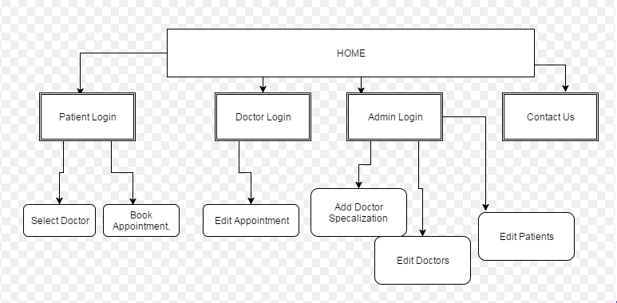

**HOME SCREEN:** 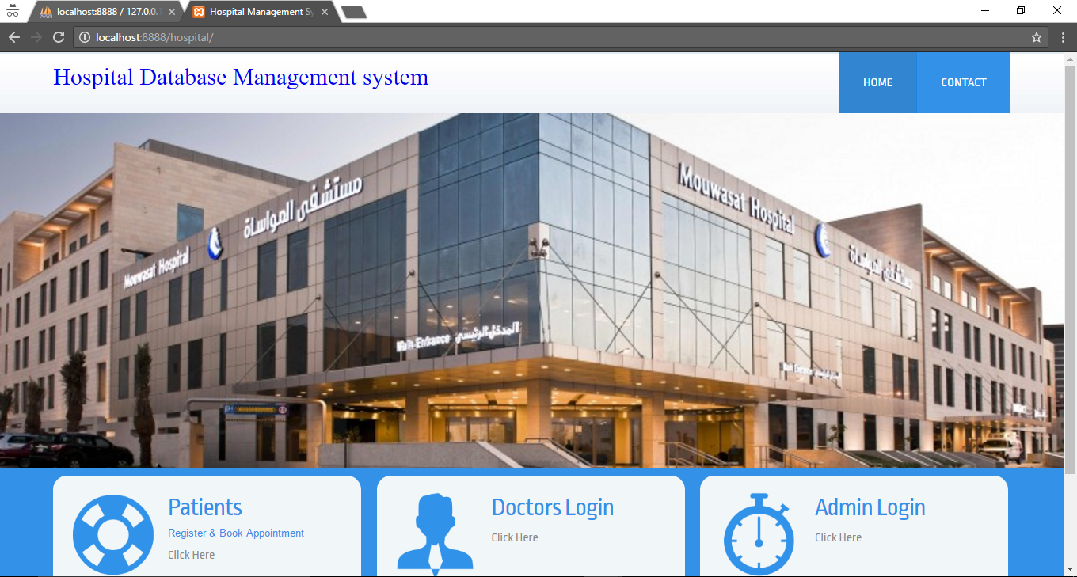

**Home Screen:**

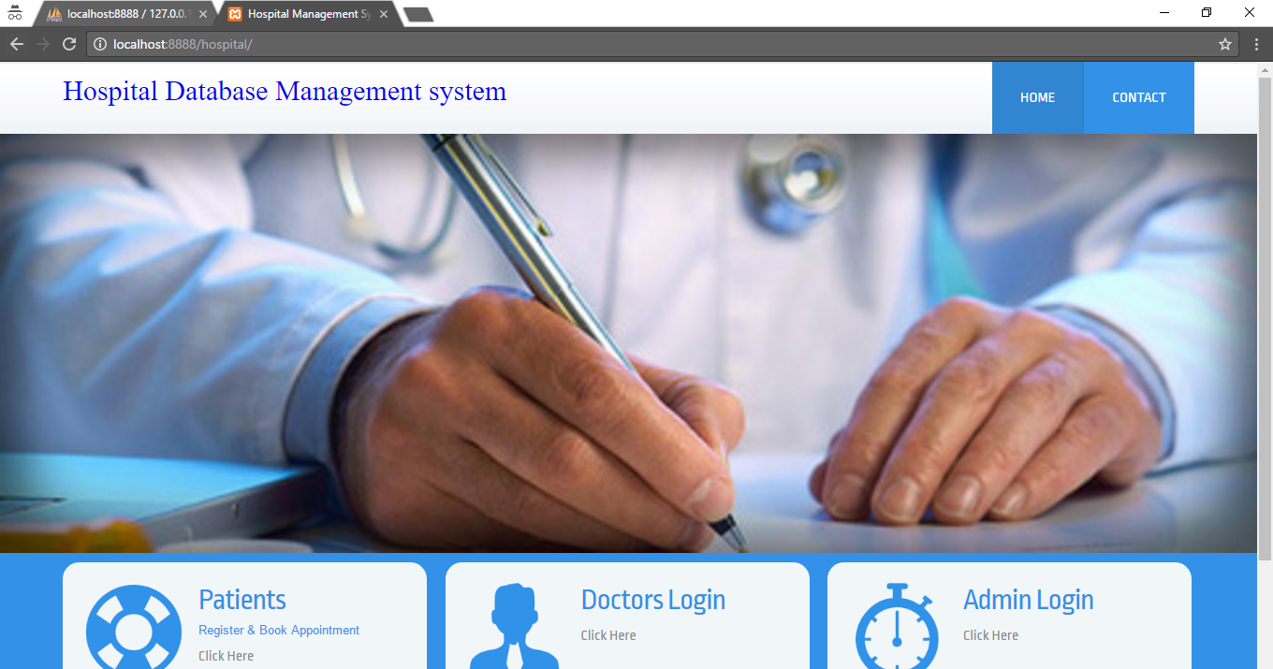

**Contact Screen:**

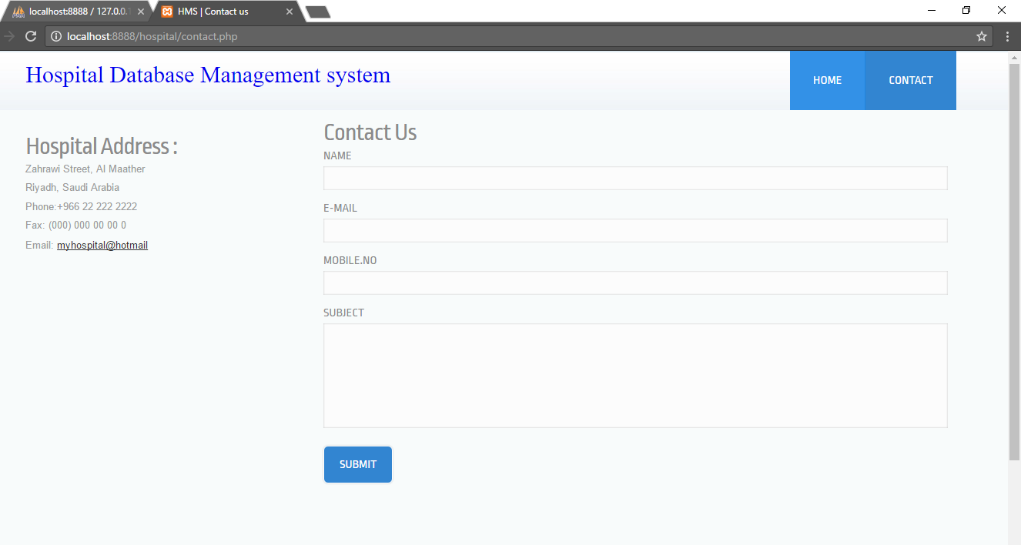

**Patient Login:**

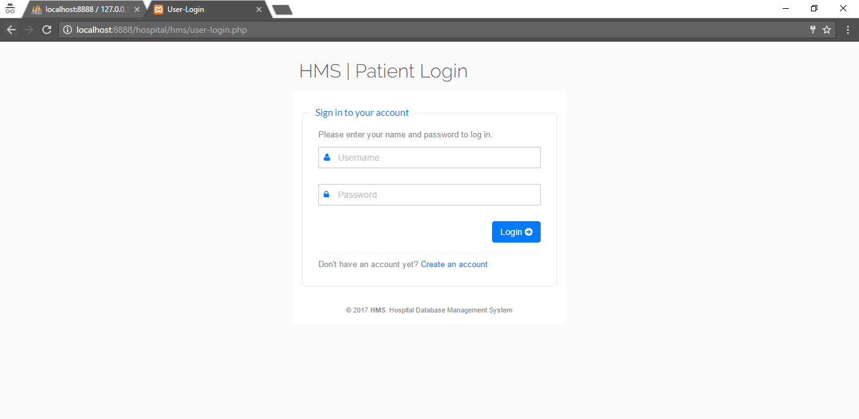

**Patient Dash Board:**

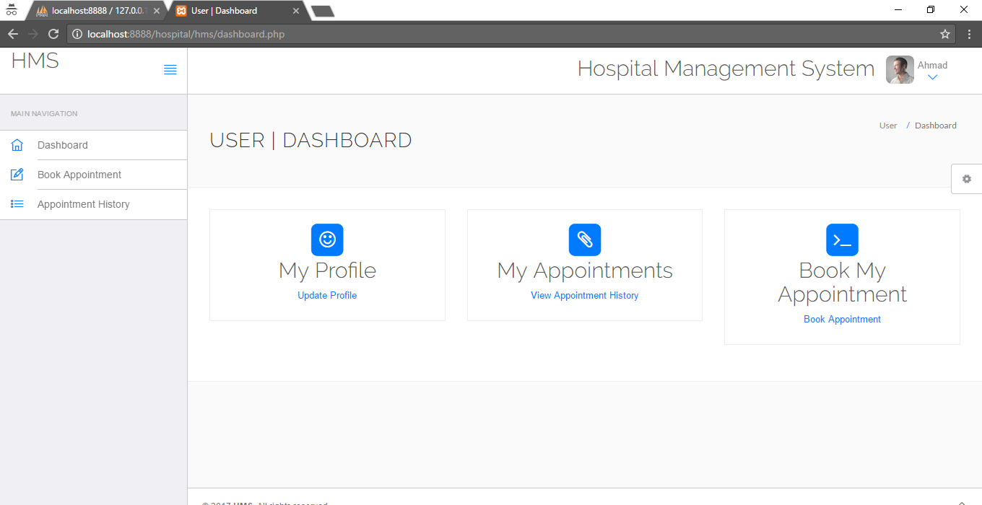

**Patient Appointment Booking:**

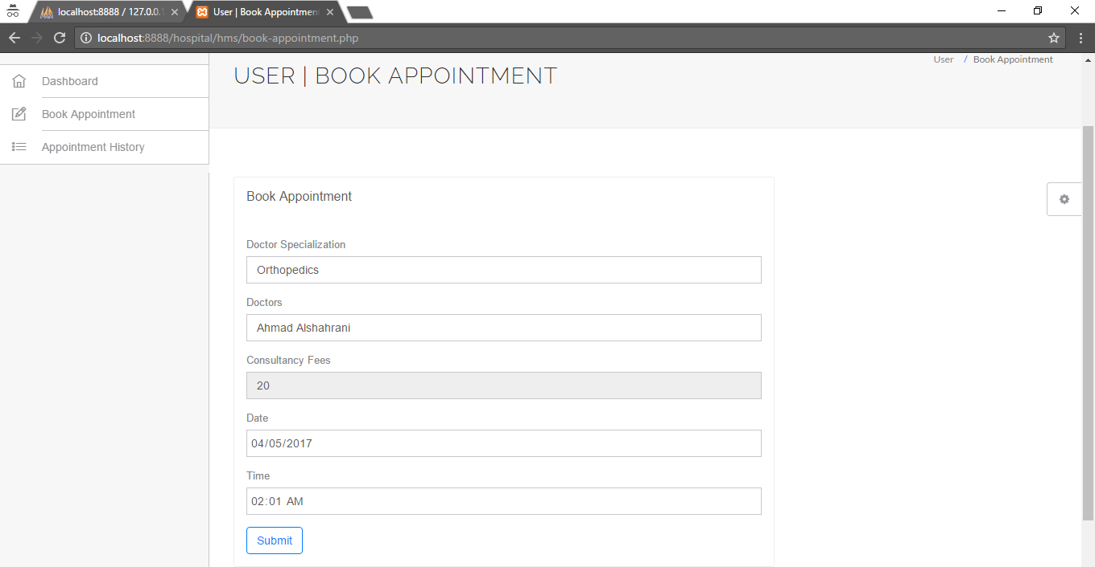

**APPOINTMENT Request stored in DB:**

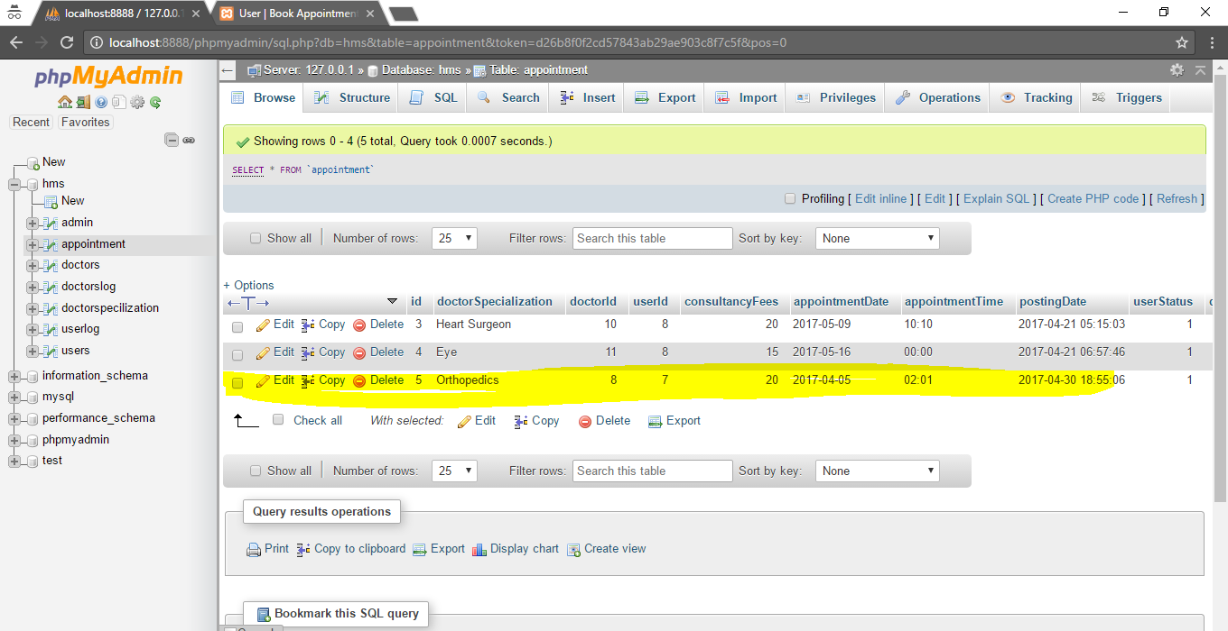

**Doctor Dashboard:**

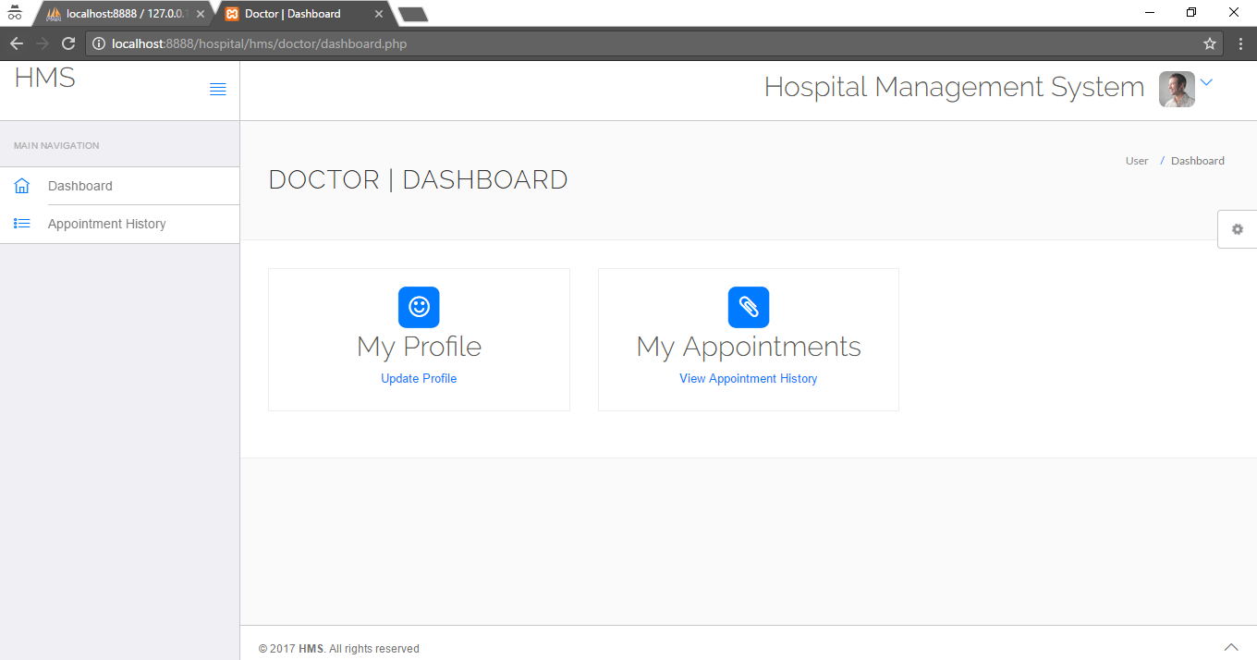

**Doctor’s Appointments:**

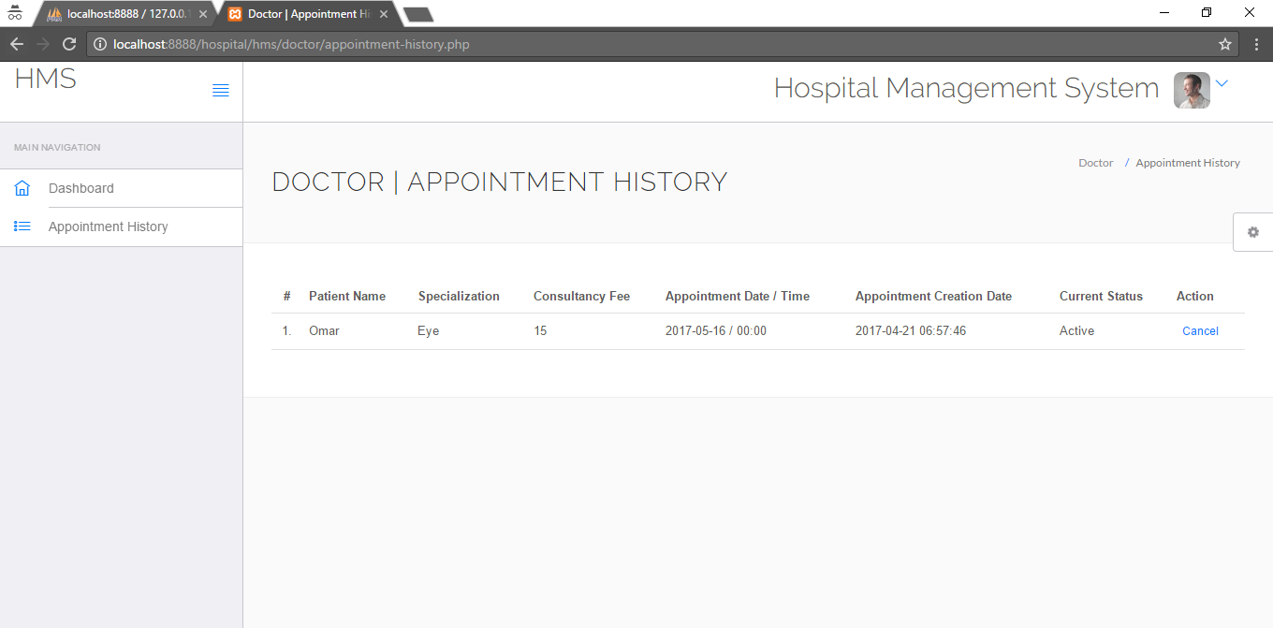

**Admin Login:**

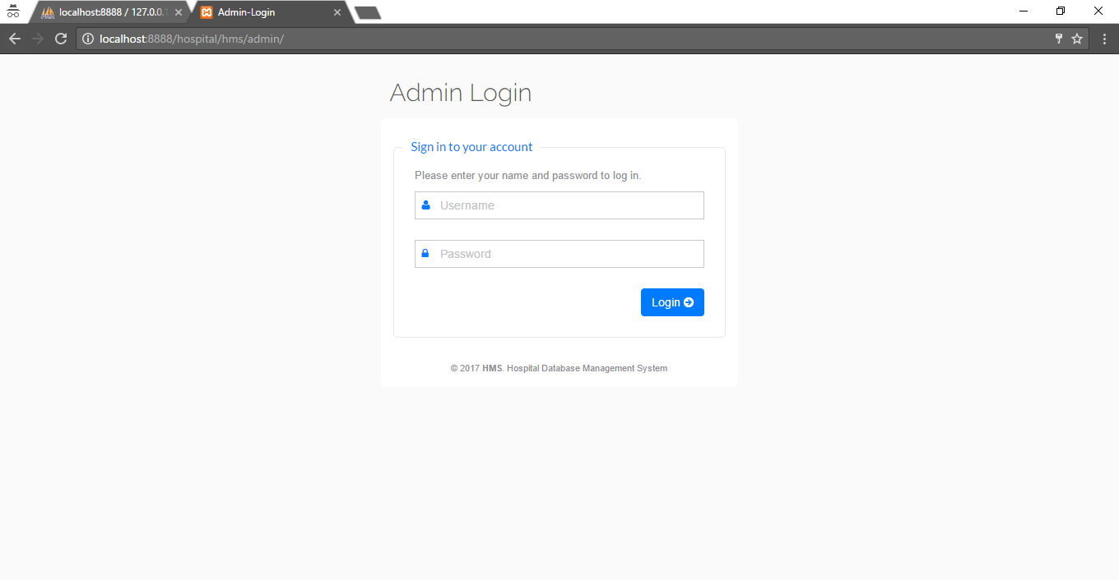

**Admin Dashboard:**

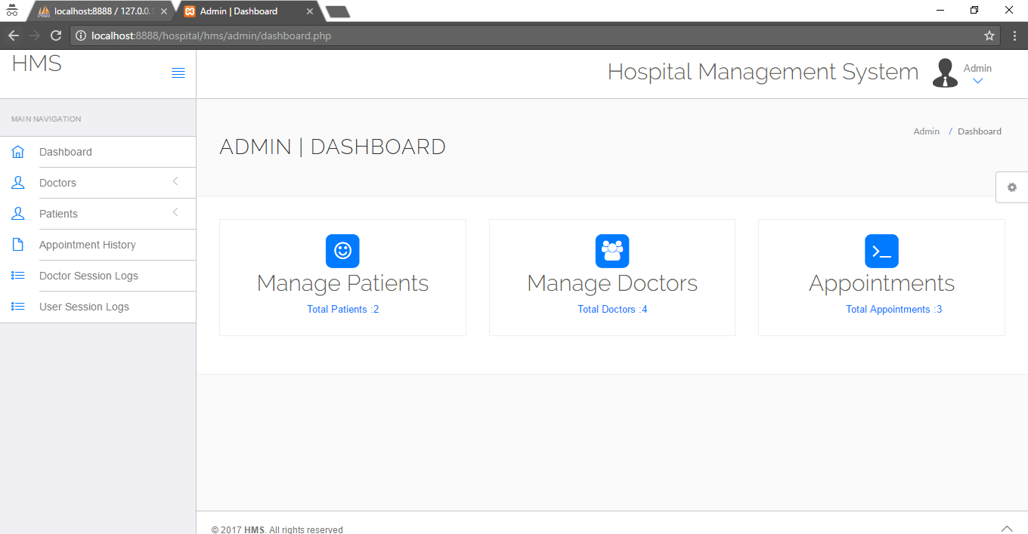

**Admin Appointment:**

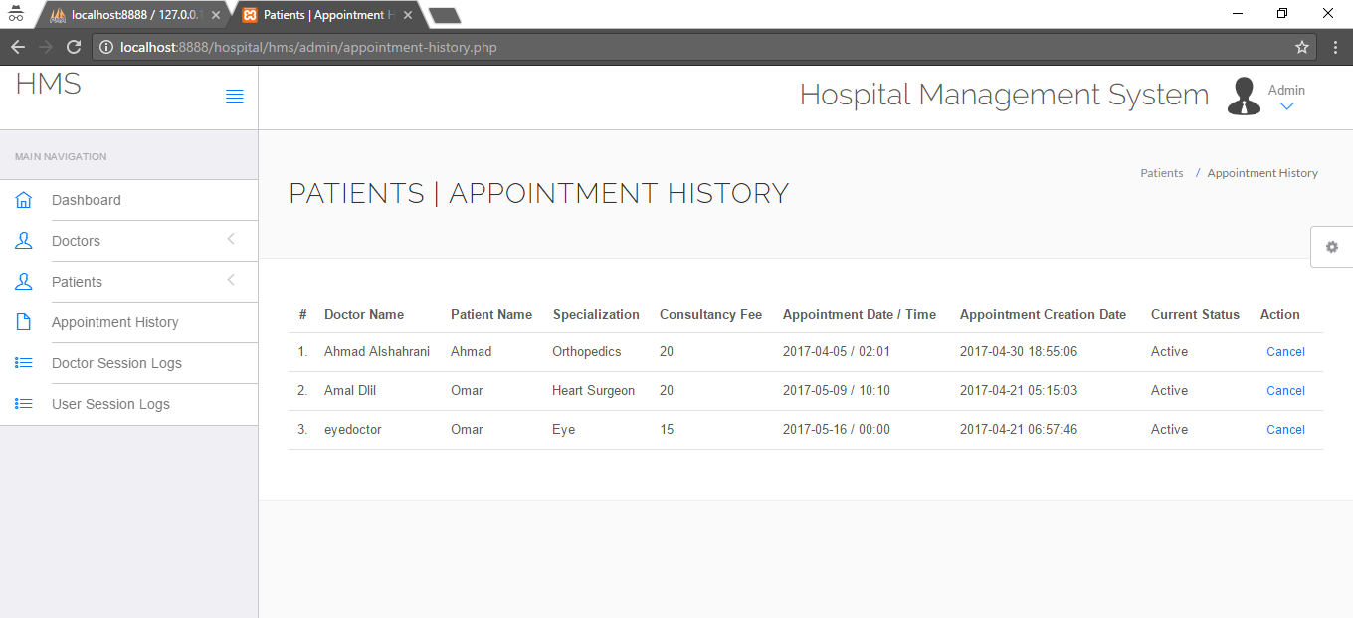

**Manage Patients:**

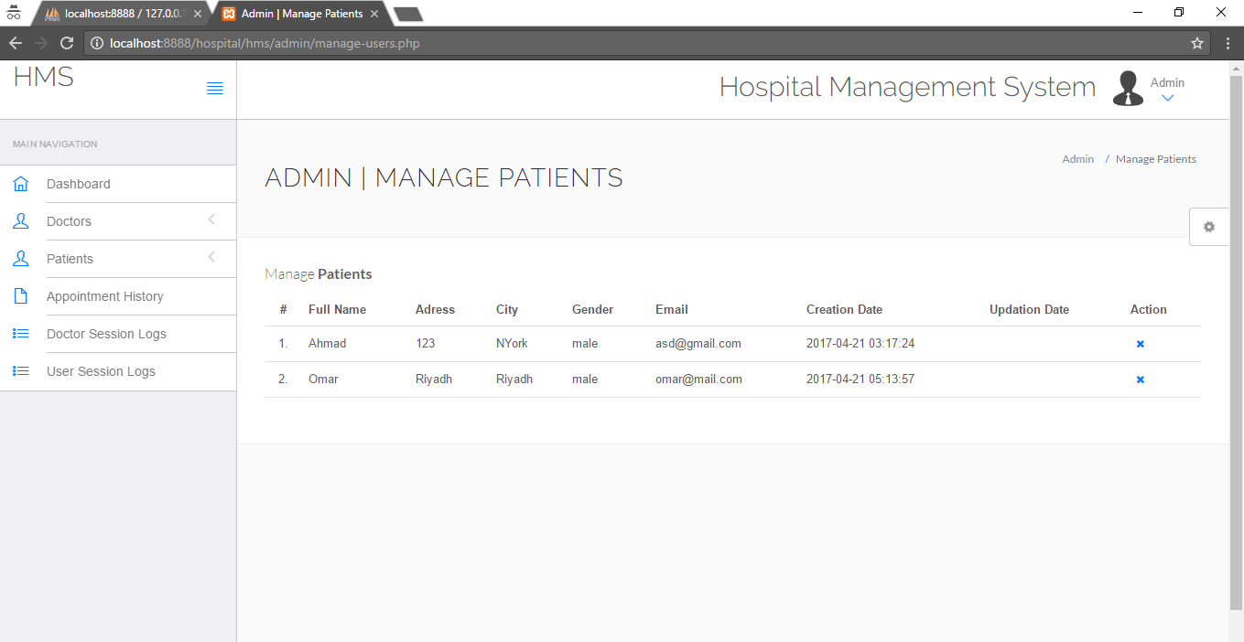

**Manage Doctors:**

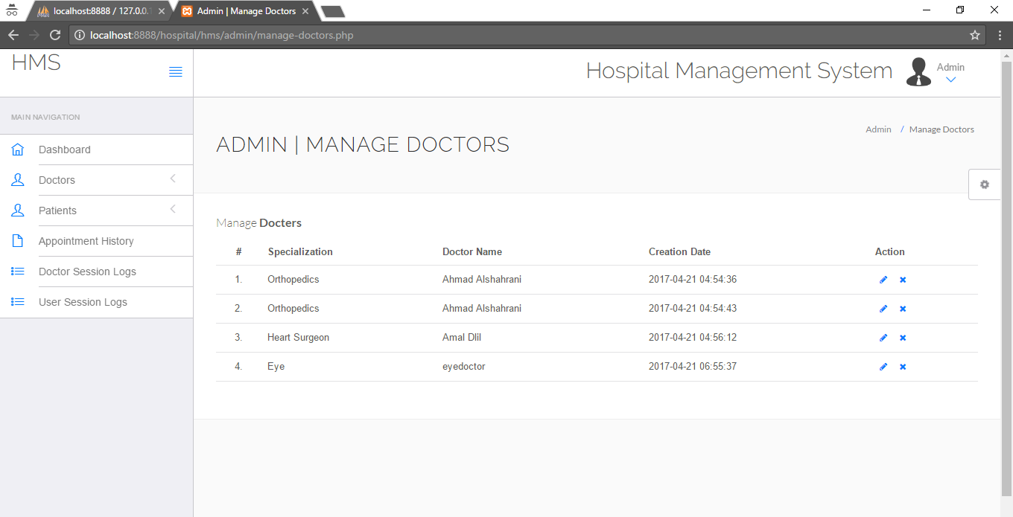

**On XAMPP server I ran my Mysql and Apache Server.**